https://www.jdoodle.com/embed/v0/5RWh
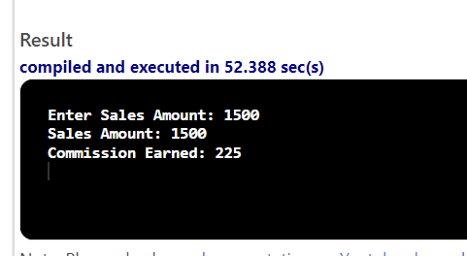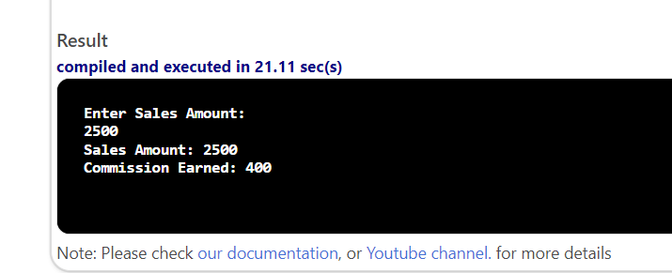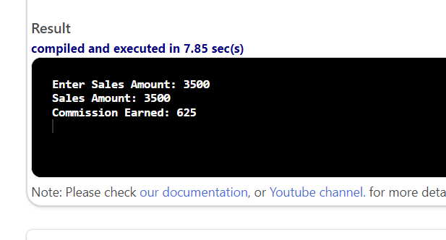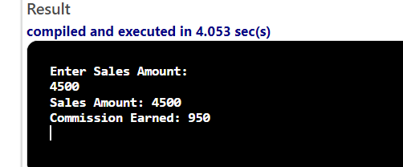

#include <iostream>

using namespace std;

int main()
{
double Sales,Commission;
cout<<"Enter Sales Amount: "<<endl;
cin>>Sales;

if (Sales <= 2000.00)
{
Commission = .15 * Sales;
}
else if (Sales <= 3000.00)
{
Commission = (.15 * 2000.00) + ( (Sales-2000.00) * .20 );
}
else if (Sales <= 3500.00)
{
Commission = (.15 * 2000.00) + (.20 * 1000.00) + ( (Sales-3000.00) * .25 ) ;
}
else if (Sales <= 4000.00)
{
Commission = (.15 * 2000.00) + (.20 * 1000.00) + (.25 * 500.00) + ( (Sales-3500.00) * .30 ) ;
}
else
{
Commission = (.15 * 2000.00) + (.20 * 1000.00) + (.25 * 500.00) +(.30 * 500.00)+ ( (Sales-4000.00) * .35) ;
}
cout<<"Sales Amount: "<<Sales<<endl;
cout<<"Commission Earned: "<<Commission<<endl;
return 0;
}

